TRAINING AND PLACEMENT CELL
ACADEMIC YEAR 2024-2025
PLACEMENT DRIVE INDIAN HEALTH CARE (BPO) on 30.01.2025
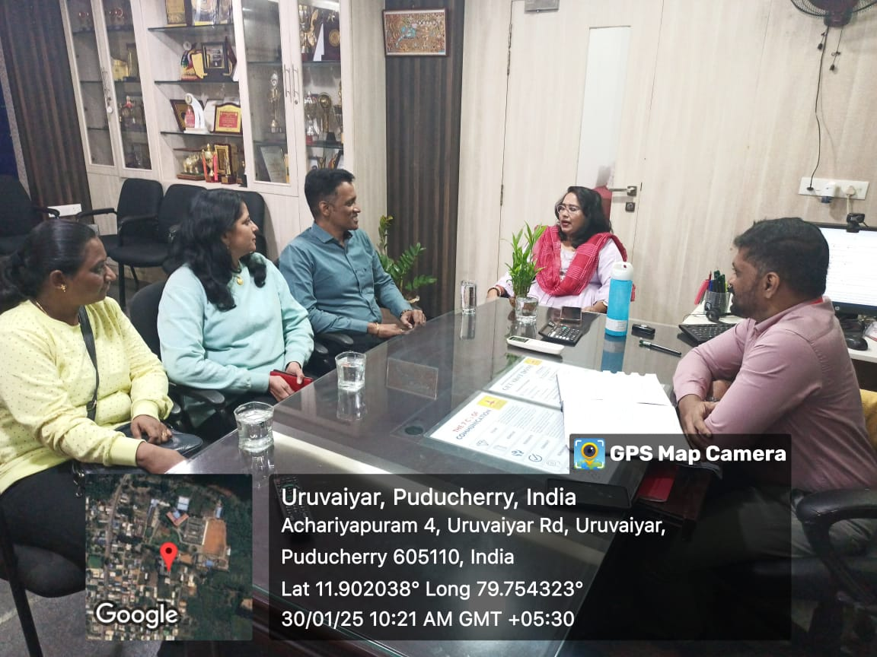
We are delighted to share that T&P cell today (30.01.2025) successfully organized a placement drive for the final-year students. The drive was conducted by Indian health care (BPO) Company Chennai. A total of 164students actively participated in the recruitment process, which included a Group discussion followed by a face to face interview. We are proud to announce that 112 students were successfully selected during this drive

